# **Application Software**

The primary function of application software is to apply the power of the computer to give users the ability to solve business and scientific problems. Many different languages can be used to develop application software, each having strengths and weaknesses. Types of Application Software To solve a particular business requirement, a company can either develop its own software or purchase off-the-shelf software. It is also possible to modify some off-the-shelf software, to tailor it such that it satisfies business of the company.

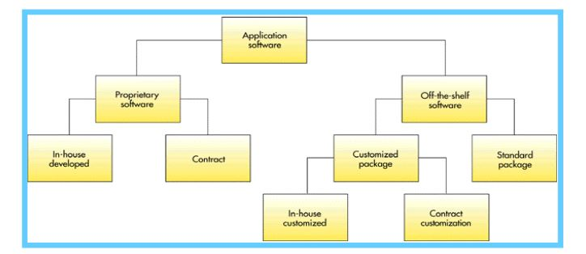

## **Proprietary Application Software**

Software that solves a unique or specific business problem of a company is called proprietary application software. This type of software is either built in-house using programmers or it can be contracted to an outside software development company. There can not be any duplication of this type of software.

## 

## **Off-the-Shelf Application Software**

A software package is a pre-written, precoded, commercially available set of programs that eliminates the need for individuals or organizations to write their own software programs for certain functions.

Application software packages are marketed commercially. These packages perform certain functionality of a business that is required by many companies, and they are available for mainframe, minicomputers, and PCs.

Examples of standard packages are, accounting, finance, auto body shop, human resources, university registration, library catalog, payroll, physician insurance claim, fax, e-mail, tax, and so on.

Customized Packages

In some cases, companies modify of-the-shelf software to accommodate business requirements of the company. Software vendors must provide the opportunity to modify their software. Again modification can be done in house or contracted to an outside company

# Personal Application Software

Personal application software includes general purpose tools and programs such as word processor, spreadsheet, graphics, database, desktop publishing, project management, computer aided design, financial management, fax, e-mail, web-browser, and so on.

These software are purchased as off-the-shelf software. Multiple software vendors may offer any type of software.

**Workgroup Application Software (Groupware)**

Groupware provides functions and services to support the collaborative activities of workgroups. It includes software for information sharing, electronic meeting, scheduling, and e-mail and a network to connect the members of the group as they work on their desktop computers.

Lotus Notes (renamed Domino) is a groupware, which provides companies to the capability of using one software, and one user interface, to integrate many business functions. For example, it can provide a global team to work on a shared set of documents or have electronic discussion following threads. A thread is a series of messages in an on-line discussion that have been posted as replies to each other.

**Enterprise Application Software**

This type of software benefits the entire organization. A fast-food chain might develop a materials ordering and distribution program to make sure that each fast-food franchise gets the necessary raw materials and supplies during the week.

Many organizations are moving to integrated enterprise software that supports supply chain management, such as, movement of raw materials from suppliers through shipment of finished goods to customers.

• Enterprise Resource Planning (ERP): ERP software is a set of integrated programs that manage vital business operations for a global enterprise. ERP supports multiple languages, multiple currencies, and multiple legal entities.

Most ERP systems support manufacturing and finance. SAP and PeopleSoft, and Oracle are leading ERP software.

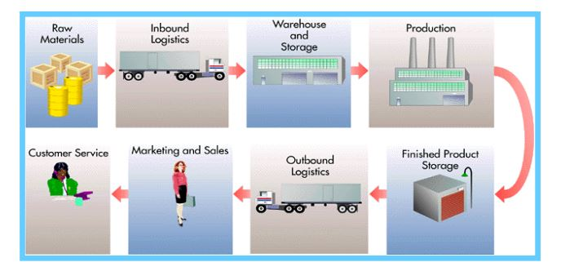

**Programming Languages**

A programming language is a computer language with its own syntax and grammar. Both systems and application software are written in programming languages. There are two types of programming languages: procedural and nonprocedural.

• Procedural Language: A procedural language tells the computer in a step-by-step fashion how to accomplish a given task.

• Non-Procedural Language: Tasks are divided into small, unrelated procedures. There are four generations of computer languages.

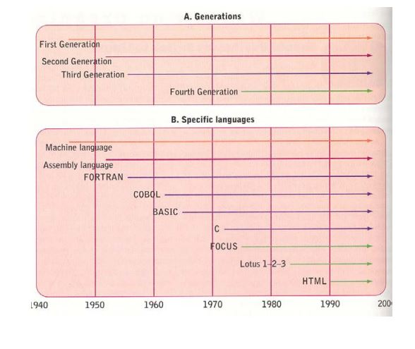

First Generation (Machine Language) In early years of computer revolution, programs were written in machine language, using the binary symbols 1 and 0. All numbers, characters and special symbols were represented by eight-bit codes. This is also considered a low-level language because there is no programming scheme less sophisticated than the binary code. Example: 00000010 00100101 00000011 == 2 + 3 Second Generation (Assembly Language) Assembly language replaced binary digits with symbols such as ADD, SUB for addition and subtraction, so that programming became more understandable to humans. Operating systems and utility programs were written in an assembly language. • Assembler: An assembler is a special program that converts assembly language into machine-readable language (1 and 0). Third Generation Languages: 3GLs (High-Level Languages) These languages were easier to use than assembly and machine language because they relied on natural language (such as English) and used fewer lines of code to execute an instruction. Some high-level languages are BASIC, COBOL, FORTRAN, and C. These languages are called high-level languages. 3GLs are machine-independent languages. That is, they are portable from one machine to another. • Compiler: A special program that converts a high-level language into machine language. 17 Fourth Generation Languages: 4GLs (Very-High-Level Languages) 4GLs are less procedural and even more English-like than third-generation languages. These are user-friendly and easy to learn. Examples are: FOCUS, SQL, HTML, and SAS. • Structured Query Languages (SQL): A standardized language often used to perform database queries and manipulations. Example: SELECT ALL FROM Employee WHERE EmpID = 1000

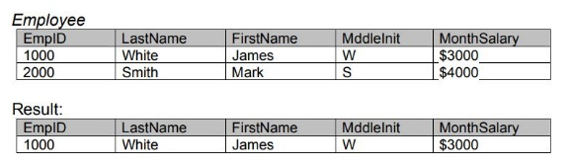

• Visual Programming Languages: Visual programming helps users create powerful and less error-prone applications in a shorter time span. It allows users to write special programs that in turn help users to select menus, buttons, and other graphical elements. Features of these languages include query and database abilities, and code-generation abilities. Examples are Visual C++, C#, Visual Basic, ASP.

Microsoft Visual Basic is the most popular business language used to develop client-server applications in the PC environment.

• Object Oriented Languages Languages that allow interaction of programming objects, including data elements and the actions that will be performed on them. An object-oriented language the world is looked as a set of objects. Each object interacts with another object based on the messages it receives. Encapsulation The process of grouping items into an object. Polymorphism A process allowing the programmer to develop one routine or set of activities that will operate on multiple objects. Inheritance Property used to describe objects in a group of objects taking on characteristics of other objects in the same group or class of objects. Reusable Code The instruction code within an object that can be reused in different programs for a variety of applications. Object Oriented Languages Small Talk, C++, C#, Java